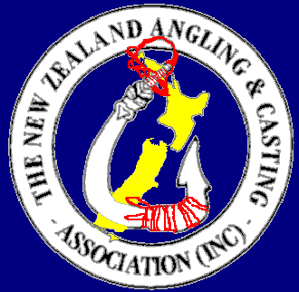
New Zealand Angling & Casting Association (Inc)
P.O. Box 12 042, Rotorua, New Zealand 3045

Ph/fax 0064 (0)7 357 4446
Email : nzaca@xtra.co.nz
or secretary@nzaca.co.nz

An Invitation

The Australian Anglers Association

Bi-Annual National Angling Championships & Convention

The AAA (Australian Anglers Association) holds their Nationals every two years hosted by different States. In 2013 it is being hosted by the Queensland Amateur Fishing Clubs Association (QAFC) on the Sunshine Coast with the Headquarters being at the great facilities of the Caloundra Boating Club.

The NZACA, being Associate Members of the AAA, have attended these Championships since 1983 and the NZ National Flag and the NZACA flag have flown at almost every Championship event since. The NZ’ers are made feel really welcome and the friendly rivalry that exists in many codes between our two countries is much in evidence on these occasions, often with great fun and frivolity. There is even a magnificent trophy – a large Maori waka donated by Air NZ – that is competed for by NZ’ers who attend.

The dates are August 6th to 22nd 2013

A one-off entry fee (A$65) covers all aspects of the fishing/casting program which comprises of 3 days offshore boat fishing, 3 days rock & beach fishing, 3 days river & estuary fishing (boat and/or shore) and 2 days dry land casting competition. Competitors do not have to compete in all events. Fishing boundaries are from Noose in the north to Bongaree in the south
There is a very comprehensive social program for non-fishers and this together with a couple of lay days in the fishing program means it is a great time to bring wives, partners and families for an Aussie holiday. Many folk who attend once keep on going back! It’s a great time – fishing & socially.
A Presentation Dinner wraps up the program on the final day.

Boat charters are reasonable but these need to be booked (best go on-line) as soon as possible (competitors own responsibility). Accommodation is of wide choice from Motor Camps to rented holiday apartments (these are often very good value) and again is competitor’s own responsibility.

Being on the Sunshine Coast means for NZ’ers this competition will never be closer or cheaper for us to attend. Air NZ does fly into the area but there are always good specials to be had flying into Brisbane which is only about an hours drive south of Caloundra.

Members of the NZ Team need to be financial members of the Association (thus also a member of a fishing club).

For further particulars, more detailed information, program, accommodation suggestions etc contact the NZACA National Secretary (see letterhead) – don’t leave it to late!!!!

Graeme Dawber
National Secretary
November.2012

